Newport GP Surgery
The Surgery, Frambury Lane, Newport, Essex, CB11 3PY
Telephone: 01799 540570 Fax: 01799 542126 www.thesurgerynewport.nhs.uk
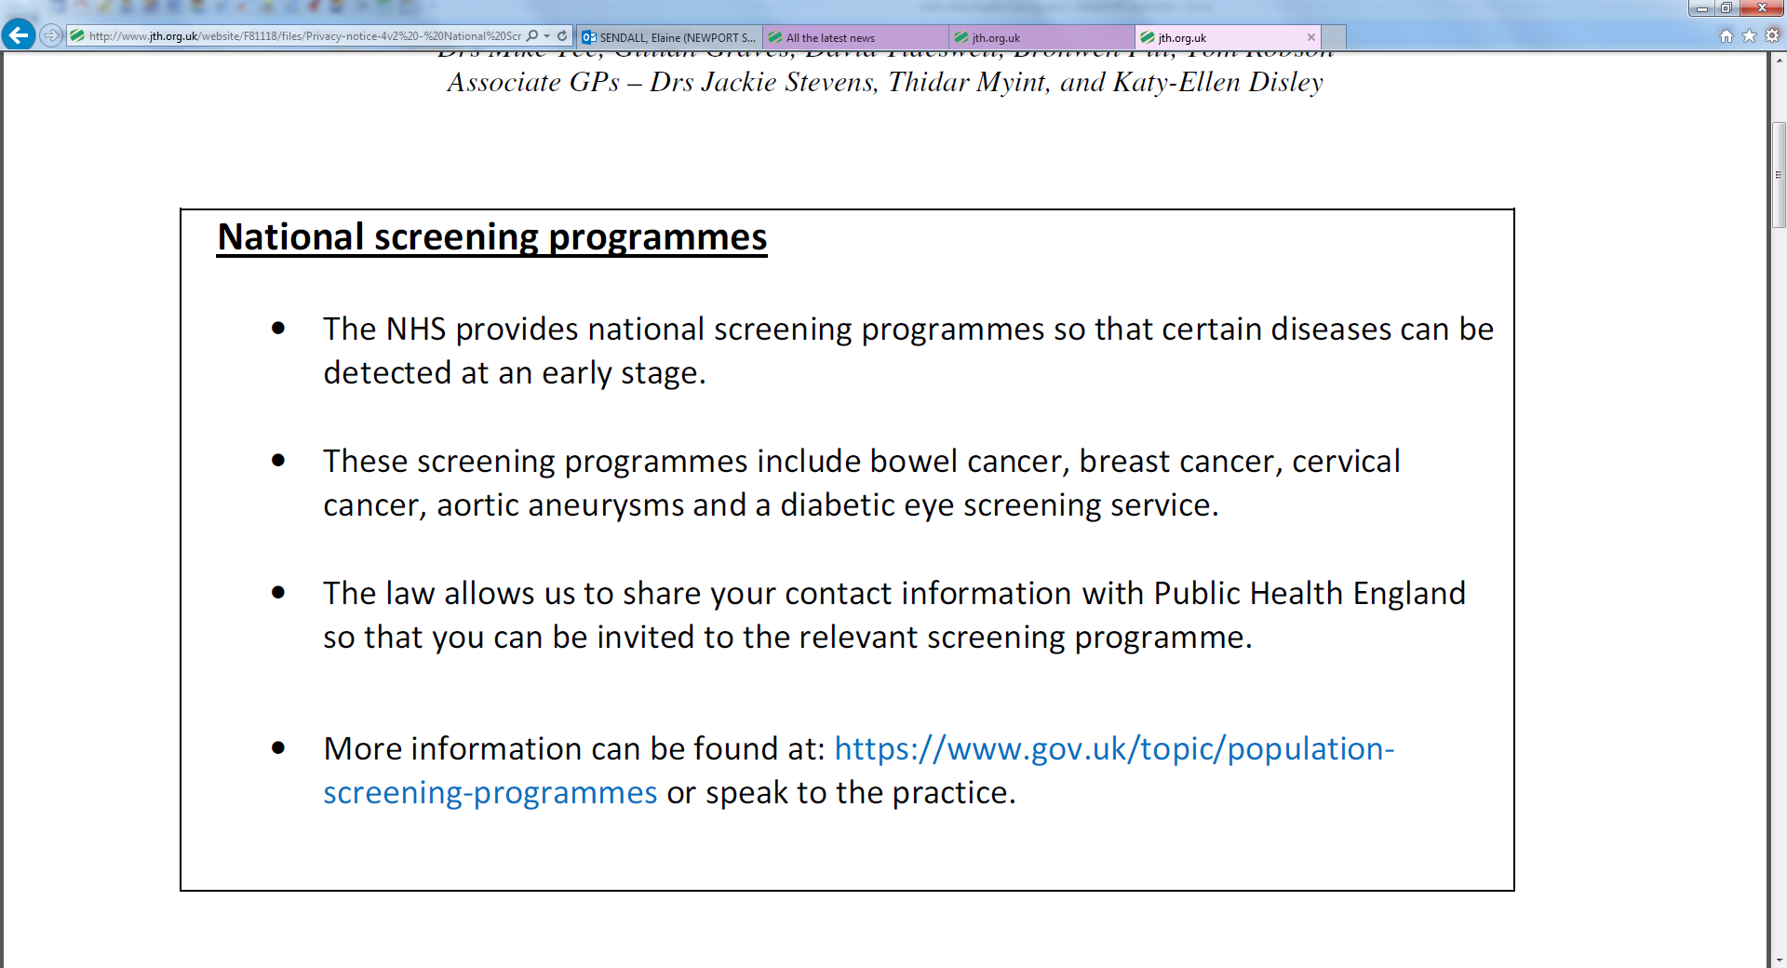

We are required by law to provide you with the following information about how we handle your information in relation to our legal obligations to share data.

Data Controller contact details | Newport GP Surgery  Frambury Lane  Newport  Essex  CB11 3PY  Tel: 01799 540570
Data Protection Officer contact details | Dr Jen West  Tel: 01799 540570  E-mail: weccg.f81034-practicemanager@nhs.net

Purpose of the processing | - The NHS provides several national health screening programmes to detect diseases or conditions early such as cervical and breast cancer, aortic aneurysm and diabetes.  - The information is shared so that the correct people are invited for screening. This means those who are most at risk can be offered treatment
Lawful basis for processing | The following sections of the GDPR allow us to contact patients for screening.  Article 6(1)(e) – ‘processing is necessary…in the exercise of official authority vested in the controller.’  Article 9(2)(h) – ‘processing is necessary for the purpose of preventative..medicine..the provision of health or social care systems and services..’
Recipient or categories of recipients of the processed data | The data will be shared with the local:  Bowel Cancer Screening Programme  Abdominal Aortic Aneurysm Screening Programme  Cervical Cancer Screening Programme  Breast Cancer Screening Programme  Diabetic Eye Screening Programme
Rights to object | For national screening programmes: you can opt so that you no longer receive an invitation to a screening programme.  See: https://www.gov.uk/government/publications/opting-out-of-the-nhs-population-screening-programmes
Right to access and correct | - You have the right to access your medical record and have any errors or mistakes corrected. Please speak to a member of staff or look at our ‘subject access request’ policy on our website  - We are not aware of any circumstances in which you will have the right to delete correct information from your medical record: although you are free to obtain your own legal advice if you believe there is no lawful purpose for which we hold the information and contact us if you hold a different view.
Retention period | GP medical records will be kept in line with the law and national guidance.  Information on how long records can be kept can be found at:  https://digital.nhs.uk/article/1202/records-management-code-of-practice-for-health-and-social-care-2016

